Using Risk Assessment Templates

Music/Podcast/Radio Studios

TV Studio

Photography Studio

Asset Capture inside on campus

Asset Capture off campus – Film

Asset Capture off campus – Other

Use the Risk Assessment Helper to find out whether your activity is suitable for using a Risk Assessment Template.
Risk Assessment Helper

If the outcome is Green, access the recommended Risk Assessment Templates. These are available in SISO under the menu option Simple Booking > Risk Assessments.
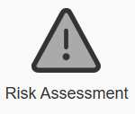
In the Risk Assessment tool, go to Open, and then select Templates. Here you should find a match to the recommended template provided by the Risk Assessment Helper tool.
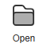 | 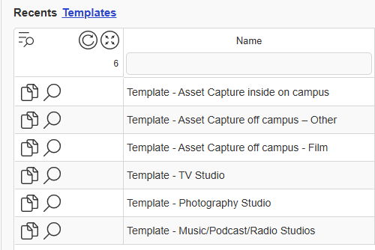  For each Template you can Preview, or Duplicate & Open.
Please read this risk assessment carefully and make sure it is an accurate description of what you intend to do in this space.

Risk Assessment Templates are pre-approved and will not need to be signed off by a member of staff.

You will, however, still need to provide information in the sections titled People, Equipment and Locations.
Duplicate & Open creates a new Risk Assessment from the template, which will allow you to add the additional required information.
Firstly, please rename it! | 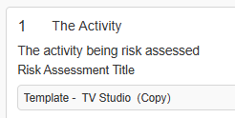
Then please ensure you complete the following sections.  This links all information to your booking.  As this is a Generic Risk Assessment it does not need approval from your lecturer. Please send this request to Generic Assessments.  Then click I agree to the terms and conditions. Then click send. This completes the process. | 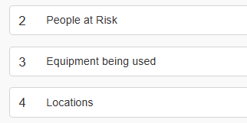  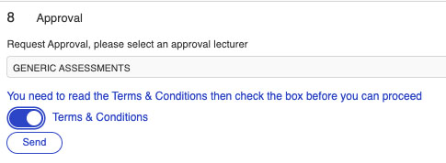

If the outcome of the Risk Assessment Helper is Yellow, select ‘No’ from the above dropdown when making your SISO equipment and/or room booking(s).
You will need to make a new risk assessment for your activity that will need to be approved by a member of staff.
If you would like to use the recommended Template as the starting point for your own Risk Assessment, you can access this in SISO under the menu option Simple Booking > Risk Assessments (as above).
Duplicate & Open creates a new Risk Assessment, which is your own, but you will find some fields already populated.
Please remember to rename it in Section 1.

Work through the Risk Assessment in the usual way.
In Section 6, click on any Hazard to edit it.
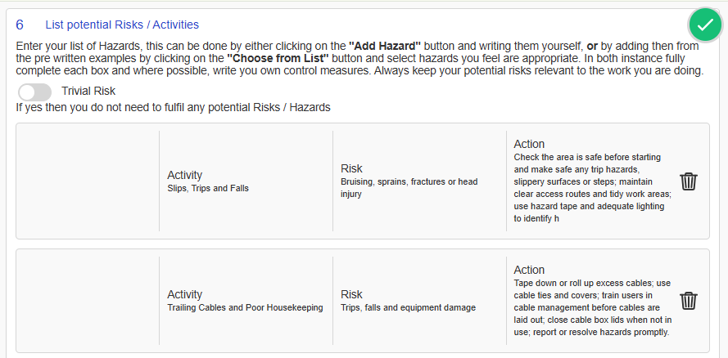
You can also delete any which are not relevant.  Add any additional Hazards in the usual way. |  | 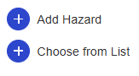
Once you’ve completed Sections 1-7 of the Risk Assessment, send to a tutor for approval in Section 8.

